Shrinkage correlation: EURUSD and EURGBP
Method 08 / eight-major panel / delta = 0.2 and Ledoit-Wolf / Alpari D1 full available history

Study setup
Logical pair: EURUSD , EURGBP
Broker symbols: EURUSD_i , EURGBP_i
Snapshot: 2026-11-03_majors_alpari_D1
Timeframe: D1
Common eight-major panel window: 1999-01-06 to 2026-11-02 (UTC bar dates)
Panel matched return count n: 7127
Dropped unfinished last bar dated 2026-11-03 UTC after a tick-volume check against the prior complete day.
Fixed shrinkage: delta=0.2, mu=3.9170889e-05 (mean of diag(S))
Ledoit-Wolf estimated delta: 0.0042157642
Panel symbols: EURUSD, GBPUSD, AUDUSD, NZDUSD, USDJPY, USDCHF, USDCAD, EURGBP
Complete matched rows (Excel): EURUSD-EURGBP_Shrinkage_D1.xlsx
Complete matched rows (HTML table): EURUSD-EURGBP_Shrinkage_D1_data.html

Method carried forward
Shrinkage blends the sample covariance matrix S of matched daily log returns of close, ln(close_t / close_t-1), toward a simple target, then converts the shrunk covariance into correlations. Quotes are not inverted. This experiment builds one common calendar across all eight majors, forms S with the unbiased n-1 divisor, then reports two shrinkage specs: fixed delta = 0.2 with mu equal to the average sample variance (mu * I target), and sklearn Ledoit-Wolf with its estimated delta. Pair reports pull rho_ij from those panel matrices. Same-panel Pearson r is a side check only. Shrinkage improves conditioning; it is not a cause, not a lead, and not a trading signal.

Results
pearson_r | rho_02 | rho_LW | rho_02_minus_r | rho_LW_minus_r | delta_LW
0.439919 | 0.325783 | 0.437314 | -0.114135 | -0.002604 | 0.00421576

Conclusion
Over the common 7127-day eight-major panel for EURUSD and EURGBP (broker quote directions unchanged), fixed-delta shrinkage correlation at delta=0.2 is 0.3258 (positive, weak linear link in this sample). Ledoit-Wolf rho is 0.4373 with estimated delta=0.004216. Same-panel Pearson r is 0.4399 (rho_02 minus r = -0.1141; rho_LW minus r = -0.0026). This does not establish cause, lead-lag, or a lasting trading rule.

Charts
Daily closes
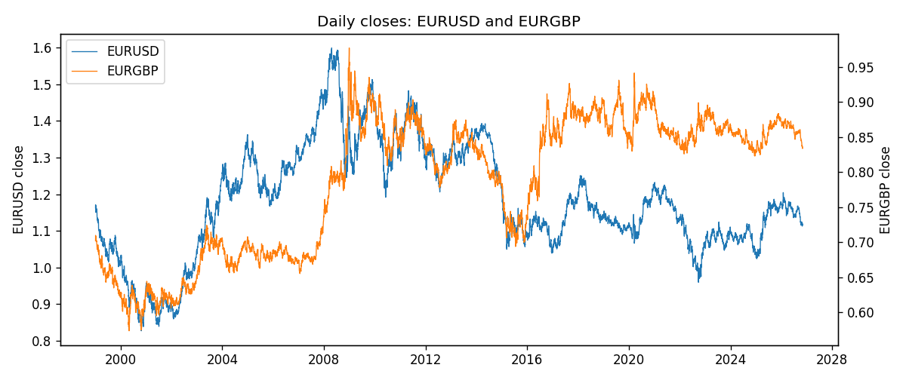
Daily log returns
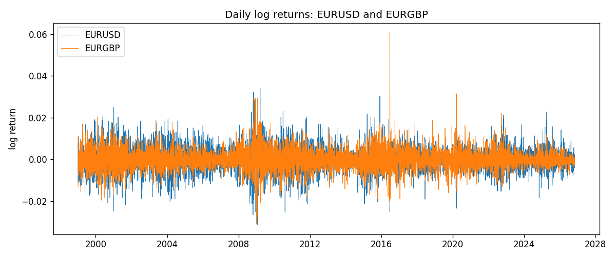
Log-return scatter
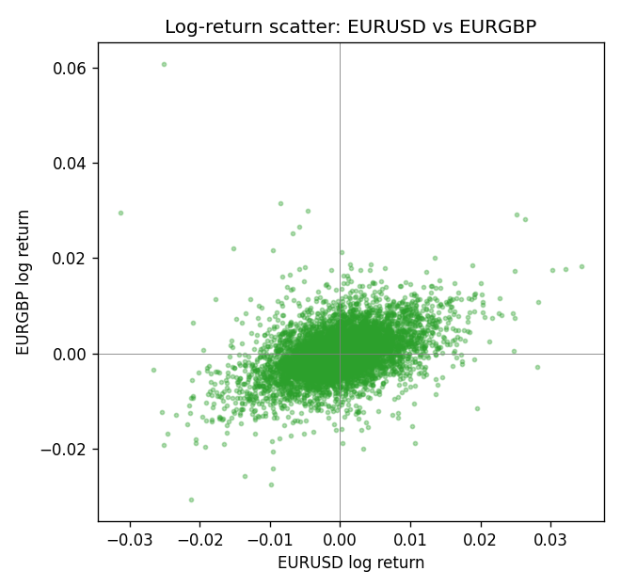

Data report
Every panel row for this pair slice is stored in the sibling Excel workbook named EURUSD-EURGBP_Shrinkage_D1.xlsx. Full-panel covariance and correlation matrices are saved once under outputs/ as CSV files. Embedding all rows as a Word table is impractical at this length; the Word file holds the column list, column summaries, and the first and last 15 matched rows.
Columns: time, EURUSD_open, EURUSD_high, EURUSD_low, EURUSD_close, EURUSD_tick_volume, EURUSD_spread, EURUSD_real_volume, EURUSD_log_return, EURGBP_open, EURGBP_high, EURGBP_low, EURGBP_close, EURGBP_tick_volume, EURGBP_spread, EURGBP_real_volume, EURGBP_log_return
Column summaries (panel rows)
column | count | mean | std | min | 25% | 50% | 75% | max
EURUSD_open | 7127 | 1.1819407 | 0.15065555 | 0.8272 | 1.086455 | 1.16615 | 1.294285 | 1.5995
EURUSD_high | 7127 | 1.1870746 | 0.15125674 | 0.8326 | 1.09055 | 1.17128 | 1.29974 | 1.6038
EURUSD_low | 7127 | 1.1769341 | 0.14996546 | 0.8227 | 1.082375 | 1.16257 | 1.288915 | 1.5865
EURUSD_close | 7127 | 1.1819858 | 0.15061943 | 0.8267 | 1.08652 | 1.16617 | 1.294345 | 1.5997
EURUSD_tick_volume | 7127 | 103994.86 | 174033.72 | 469 | 9542.5 | 53148 | 99923.5 | 1471626
EURUSD_spread | 7127 | 19.176652 | 16.472988 | 0 | 8 | 12 | 20 | 50
EURUSD_real_volume | 7127 | 4.0656436e+10 | 1.6756658e+11 | 0 | 0 | 0 | 0 | 3.6149665e+12
EURUSD_log_return | 7127 | -3.8e-07 | 0.00580028 | -0.03123819 | -0.00324243 | 8.31e-06 | 0.00325629 | 0.03433183
EURGBP_open | 7127 | 0.78791082 | 0.09637243 | 0.5734 | 0.6884 | 0.83449 | 0.8655 | 0.9769
EURGBP_high | 7127 | 0.79099288 | 0.09674788 | 0.5789 | 0.6906 | 0.83742 | 0.868415 | 0.9799
EURGBP_low | 7127 | 0.78520819 | 0.09619038 | 0.5682 | 0.6864 | 0.83222 | 0.86303 | 0.9661
EURGBP_close | 7127 | 0.7879552 | 0.09637142 | 0.5735 | 0.6884 | 0.83458 | 0.86556 | 0.977
EURGBP_tick_volume | 7127 | 87771.585 | 145890.89 | 332 | 6734 | 44866 | 82002 | 1424684
EURGBP_spread | 7127 | 21.129928 | 19.050945 | 0 | 4 | 13 | 40 | 50
EURGBP_real_volume | 7127 | 2.8086114e+10 | 1.3572254e+11 | 0 | 0 | 0 | 0 | 3.5726265e+12
EURGBP_log_return | 7127 | 2.379e-05 | 0.00487339 | -0.03067367 | -0.00262314 | -9.978e-05 | 0.00256668 | 0.06075387
First 15 panel rows (selected columns)
time | EURUSD_close | EURGBP_close | EURUSD_log_return | EURGBP_log_return
1999-01-06 | 1.1623 | 0.7019 | -0.011547966 | -0.013303338
1999-01-07 | 1.1712 | 0.7097 | 0.0076280636 | 0.011051402
1999-01-08 | 1.1585 | 0.7062 | -0.010902799 | -0.004943862
1999-01-11 | 1.1503 | 0.7053 | -0.007103287 | -0.0012752393
1999-01-12 | 1.1555 | 0.7077 | 0.0045103728 | 0.0033970309
1999-01-13 | 1.1681 | 0.708 | 0.010845346 | 0.00042381861
1999-01-14 | 1.1681 | 0.7066 | 0 | -0.0019793588
1999-01-15 | 1.1563 | 0.7012 | -0.010153245 | -0.0076715819
1999-01-18 | 1.1605 | 0.7017 | 0.0036256946 | 0.00071280921
1999-01-19 | 1.1603 | 0.7007 | -0.00017235436 | -0.0014261269
1999-01-20 | 1.1566 | 0.7021 | -0.0031939256 | 0.0019960086
1999-01-21 | 1.1601 | 0.7016 | 0.0030215416 | -0.00071240297
1999-01-22 | 1.1587 | 0.7004 | -0.0012075213 | -0.0017118406
1999-01-25 | 1.1552 | 0.6966 | -0.0030251979 | -0.0054402425
1999-01-26 | 1.1562 | 0.6962 | 0.00086527651 | -0.00057438255
Last 15 panel rows (selected columns)
time | EURUSD_close | EURGBP_close | EURUSD_log_return | EURGBP_log_return
2026-10-13 | 1.11965 | 0.84458 | 0.0037402957 | 0.00020130374
2026-10-14 | 1.11545 | 0.84553 | -0.0037582255 | 0.0011241873
2026-10-15 | 1.12172 | 0.84479 | 0.0056053107 | -0.00087557391
2026-10-16 | 1.12371 | 0.84307 | 0.0017724895 | -0.0020380844
2026-10-19 | 1.12086 | 0.84259 | -0.0025394633 | -0.00056950988
2026-10-20 | 1.12354 | 0.83957 | 0.0023881672 | -0.0035906254
2026-10-21 | 1.12318 | 0.83839 | -0.00032046717 | -0.00140647
2026-10-22 | 1.12139 | 0.83682 | -0.0015949606 | -0.0018743924
2026-10-23 | 1.11989 | 0.83751 | -0.001338521 | 0.00082421033
2026-10-26 | 1.11735 | 0.83762 | -0.0022706559 | 0.00013133309
2026-10-27 | 1.11272 | 0.83595 | -0.004152342 | -0.0019957343
2026-10-28 | 1.1152 | 0.83651 | 0.0022262927 | 0.00066967224
2026-10-29 | 1.11772 | 0.83553 | 0.0022571351 | -0.0011722209
2026-10-30 | 1.11644 | 0.83351 | -0.0011458446 | -0.0024205543
2026-11-02 | 1.11881 | 0.83426 | 0.002120569 | 0.00089940465

